Design and development of 4 bit binary lock with memory register
Micro Project Report
Submitted for the Micro Project-I Evaluation
Bachelor of Technology
In
Computer Science & Design
Submitted By
BTCD2501144
Tejaswa Daboria
Faculty Mentor
Dr Pooja Mishra
Assistant Professor
Department of Computer Science & Engineering




July-Dec 2025

Declaration by the Candidate
I hereby declare that the work entitled “Temperature and humidity monitoring” is my work, conducted under the supervision of Dr. Pooja Mishra, Assistant Professor, during the session July-Dec. 2025. The report submitted by me is a record of bonafide work carried out by me.
I further declare that the work reported in this report has not been submitted and will not be submitted, either in part or in full, for the award of any other degree or diploma in this institute or any other institute or university.
--------------------------------
Tejaswa Daboria
BTCD25O1143
Date:27-11-2025
Place: Gwalior
This is to certify that the above statement made by the candidates is correct to the best of my knowledge and belief.
Guided By:
______________
DR. Pooja Mishra
Assistant Professor
Computer Science and Engineering
MITS, Gwalior

Lab Coordinator

_________________
Dr. Jaimala jha
Assistant Professor
Computer Science and Engineeringd
MITS, Gwalior

Abstract

This project is a 4 bit binary lock with memory which is made to provide simple security using digital electronics. The main idea is that user have to enter 4 bit input and the system checks it with the 4 bits stored in memory inside the circuit. If the input is correct, the lock opens, otherwise it remain locked. The project is made using basic logic gate and latch ICs from 74 and 40 series CMOS ICs. It is very simple but show how digital circuits can be use in real life for security purpose. The memory part stores the code only while the circuit is powered on, so it forgets the code when power is off. This project also helps beginners to understand how logic gates and latches work together to perform a useful function. It is small and easy to understand project but it demonstrate important concept of digital electronics and temporary memory usage in security systems.

Acknowledgement

We express our sincere indebtedness towards our guide Dr. Pooja Mishra, Computer Science & Engineering, Madhav Institute of Technology & Science, Gwalior for his invaluable guidance, suggestions and supervision throughout the work. Without his kind patronage and guidance, the project would not have taken shape. We would also like to express our gratitude and sincere regards for his kind approval of the project, time to time counselling and advices.
I would also like to thank to our HOD Dr. Manish Dixit, Department of Computer Science & Engineering, Madhav Institute of Technology and Science, Gwalior for his expert advice and counselling from time to time.
I owe sincere thanks to all the faculty members in the department of Computer Science and Engineering for their kind guidance and encouragement from time to time.

Date: 27th November 2025 Tejaswa
Daboria
BTCD25O1143

TABLE OF CONTENT

Declaration by the Candidate………………………………………………...ii
Abstract……………………………………………………………………....iii
Acknowledgement…………………………………………………………...iv
Content……………………………………………………………………….v
Nomenclature………………………………………………………………...vi
List of Figures………………………………………………………………..vii
Introduction…………………………………………………………………..1
Objective……………………………………………………………………..2
Workflow…………………………………………………………………….3
Methodology…………………………………………………………………4
Progress………………………………………………………………………5
Result and Analysis………………………………………………………..…9
Conclusion…………………………………………………..………………..14
Bibliography…………………………………….……………..……………….…….……15

NOMENCLATURE

Abbreviation / Symbol | Description
IC | Integrated circuit
CMOS | Complememtary metal oxide semiconductor
Bit | A binary digit
Latch | Used to store memory (SR Latch using CD4043 IC)

LIST OF FIGURES

Page No. | FIGURE NUMBER | FIGURE NAME
3 | Figure 1 | Diagram I made online to check its working
5 | Figure 2 | Working prototype

INTRODUCTION

In todays world, security system is very important to protect things from unauthorized access. Digital electronics provide simple and effective way to make such security systems. This project is a 4 bit binary lock with memory, which is designed to check user input and compare it with a code stored in the circuit. If the input is correct, the lock opens, otherwise it remain locked.
The project is made using basic logic gates and latch ICs from 74 and 40 series CMOS ICs, and all the components are wired carefully on a perfboard. The memory in this system is temporary and store the code only while the circuit is powered on. Wiring it on perfboard make the project compact and easy to handle. This project help students and beginners to understand how digital logic and temporary memory can be used in real life for security applications. It also show how simple components can work together to perform a useful function.

OBJECTIVE

The main objective of this project is to design and build a simple 4 bit binary lock with memory using basic digital electronics components. It is made to check user input and compare it with the stored code, and unlock only if the input is correct. The project also aims to help students and beginners understand the working of logic gates, latch ICs, and temporary memory in a practical circuit. Another objective is to make the project compact and easy to handle by wiring it on a perfboard.

WORKFLOW

- First, the whole circuit was designed online using Logicly software to check how the logic gates and latches will work together.
- After finalizing the design, the required ICs from 74 and 40 series were ordered.

- Then, the components were carefully wired on a perfboard according to the design.

- Around one day was given for testing, debugging, and rewiring wherever needed.

- After fixing all the issues, the circuit worked perfectly as expected, and the 4 bit binary lock was fully functional.

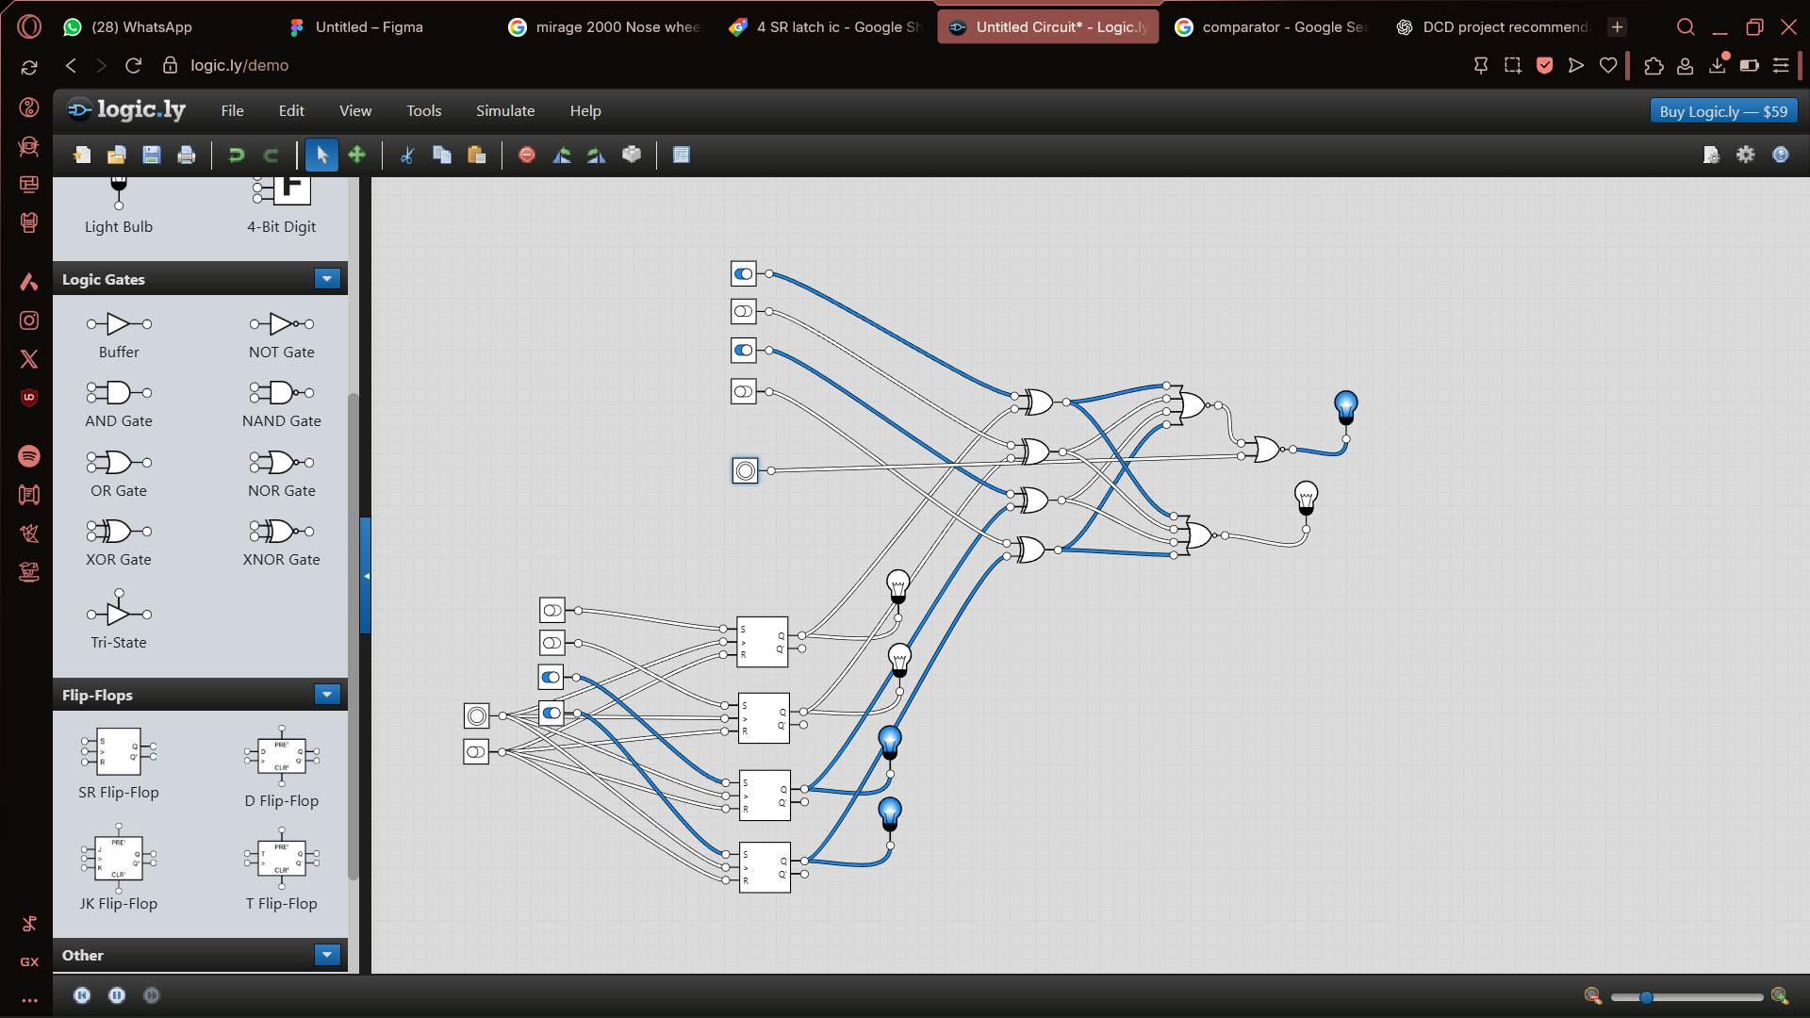
Figure 1: Logicly Design that I madde online

METHODOLOGY

First, the circuit was designed logically using Logicly software to make sure all logic gates and latch ICs work correctly together. The design was tested and modified online until it gave the correct output for all possible 4 bit inputs.
After finalizing the design, the required ICs from 74 and 40 series CMOS were ordered. All components like ICs, resistors, and switches were then wired on a perfboard according to the design. Care was taken to connect the ICs properly and avoid loose connections.
Once the wiring was complete, the circuit was powered on and tested. Some connections needed to be rewired or corrected, so around one day was spent for debugging and making sure everything works perfectly. After all testing, the 4 bit binary lock worked as expected, checking the user input against the stored code and unlocking only when the input was correct.
This methodology shows a simple way to design, build, and test a digital circuit using logic gates and latch ICs, and helps beginners understand how temporary memory and digital logic work together.

PROGRESS

The project is now fully completed. All the ICs and other components have been wired on the perfboard according to the design. The circuit has been tested and it works perfectly. When the 4 bit code entered by the user is same as the code stored in the memory, the LED lights up to indicate that the lock is opened. All connections are checked and the circuit is stable. The project is now ready for demonstration and shows how logic gates and latch ICs can be used to make a simple 4 bit binary lock.

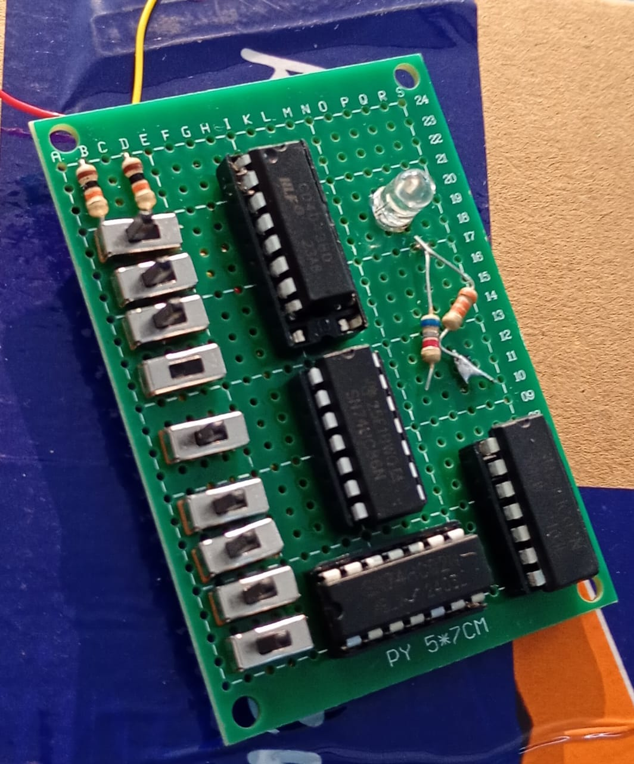
Figure 3: Built circuit

RESULT AND ANALYSIS

The 4 bit binary lock with memory works as expected. When I enter the correct 4 bit code, the LED lights up showing that the lock is open. If the wrong code is entered, the LED stays off and the lock remain closed. The circuit is stable and all connections on the perfboard are correct.
Analysis shows that the logic gates and latch ICs work together properly to compare the input with the stored code. Temporary memory stores the code only while power is on, and the circuit responds immediately to user input. While building the project, I also found the importance of pullup resistors to make the circuit work reliably. This project successfully demonstrates how digital circuits can be used for simple security systems using basic components.

CONCLUSION

In this project, I successfully designed and built a 4 bit binary lock with memory using logic gates and latch ICs from 74 and 40 series. The circuit works perfectly and the LED lights up when the user enters the correct code. I also learned the importance of using pullup resistors to make the circuit reliable. Wiring the components on a perfboard made the project compact and easy to handle. Overall, this project helped me understand how digital logic and temporary memory can be used to make simple security systems using basic and raw electronics components.

BIBLOGRAPHY

  - Logic.ly
  - Divine intellect

